TWITTER STOCK MARKET ANALYSIS
Using Python & Power BI
Project Report
Submitted by
Rohitha Iyer

Table of Contents
- Introduction
- Project Objective
- Dataset Description
- Data Cleaning & Preprocessing
- Statistical Analysis
- Hypothesis Testing
  - T-Test
  - Chi-Square Test
- Data Visualization
- Interactive Time Analysis
- Timeline Analysis
- Power BI Dashboard
- Key Insights
- Conclusion

Introduction
The stock market is one of the most important indicators of a company’s financial performance and investor confidence. Analysing historical stock prices helps identify market trends, price volatility and trading behaviour, enabling investors and analysts to make informed decisions.
This project focuses on analysing Twitter’s historical stock market data using Python and Power BI. Python was used for data cleaning, statistical analysis, hypothesis testing and data visualization, while Power BI was used to build an interactive dashboard. The project demonstrates how data analytics techniques can be applied to transform raw financial data into meaningful business insights.

Project Objective
OBJECTIVE
The primary objective of this project is to analyse Twitter’s historical stock market performance using Python and Power BI. The project aims to explore stock price trends, perform statistical analysis, visualize market behaviour and develop an interactive dashboard to support data-driven decision-making.
Specific Objectives
- Analyse Twitter’s historical stock price data from 2018 to 2024.
- Perform data cleaning and preprocessing to improve data quality.
- Generate descriptive statistics to summarize the dataset.
- Conduct hypothesis testing using the Independent T-Test and Chi-Square Test.
- Create visualizations to identify trends and price movements.
- Develop an interactive Power BI dashboard for business analysis.
- Derive meaningful insights from the analysis to understand Twitter’s stock performance.

Dataset Description
Overview
The dataset used in this project contains the historical daily stock prices of Twitter from 2018 to 2024. Each row represents the trading activity for one day.
Dataset Features
Column | Description
Date | Trading date
Open | Opening Stock Price
High | Highest price during day
Low | Lowest price during day
Close | Closing stock price
Adj Close | Adjusted closing price
Volume | Number of shares traded

Dataset Summary
- Total records before cleaning: 2,264
- Total records after cleaning: 2,259
- Missing values were removed using dropna() method
- Dataset used for statistical analysis and visualization
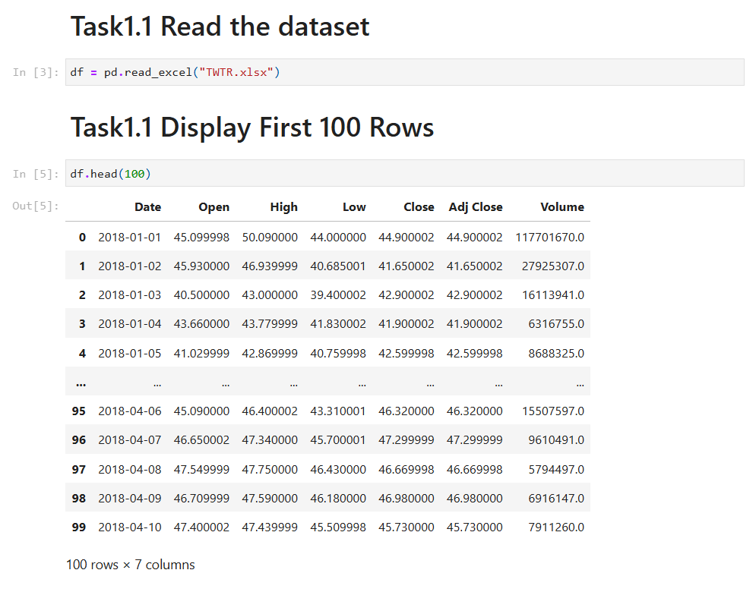
Fig.1 – Preview of the Twitter stock market dataset used for analysis.

Data Cleaning & Preprocessing
Overview
Before performing statistical analysis and visualization, the dataset was examined for missing values and inconsistencies. Data preprocessing was carried out to ensure accuracy and reliability in the analysis.
Data Cleaning Steps
- Imported dataset into Python using the Pandas library.
- Checked dataset structure and data types.
- Identified missing values in each column using df.isnull().sum()
- Removed rows containing missing values using the dropna()
- Verified the cleaned dataset by checking its dimensions using df.shape
Dataset Summary After Cleaning
- Initial number of records: 2,264
- Final number of records: 2,259
- Missing values removed: 5
- The cleaned dataset was used for all subsequent statistical analyses and visualizations.
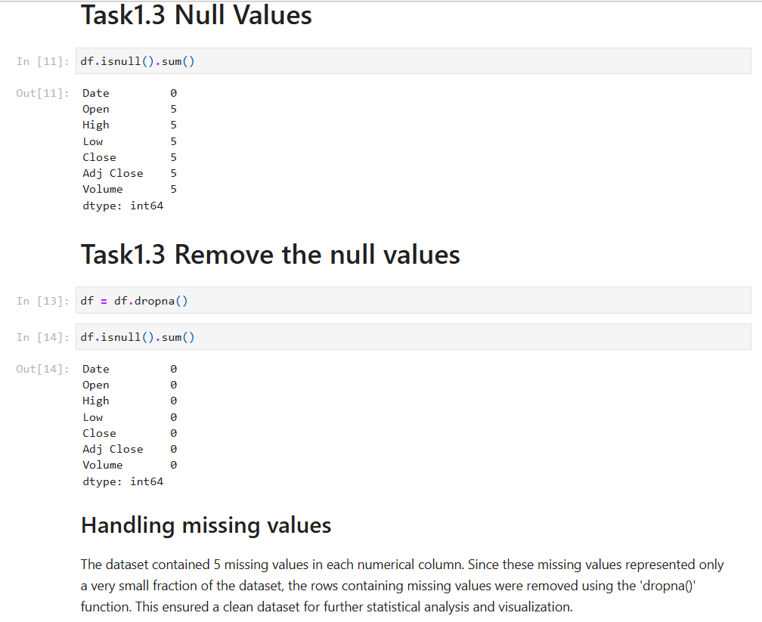Fig.2 – Missing values before and after cleaning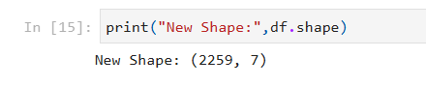
Fig.3 – Dataset Shape After Cleaning

Statistical Analysis
Overview
Descriptive statistical analysis was performed to summarize the key characteristics of Twitter’s historical stock market data. The describe() function in the Pandas library was used to calculate statistical measures such as count, mean, minimum, maximum, quartiles and standard deviation.
Descriptive Statistics of the Dataset
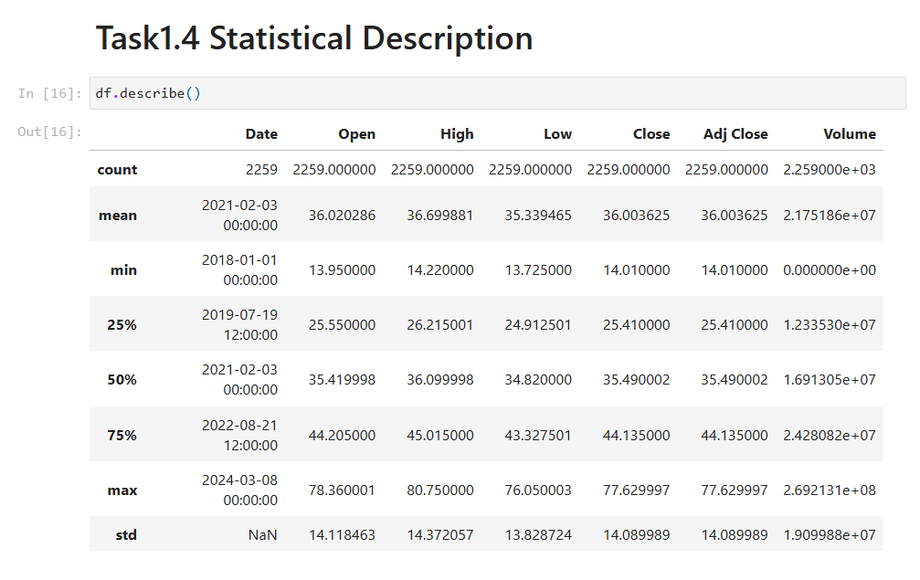
Fig.4 - Descriptive Statistics of the Dataset
Statistical Summary
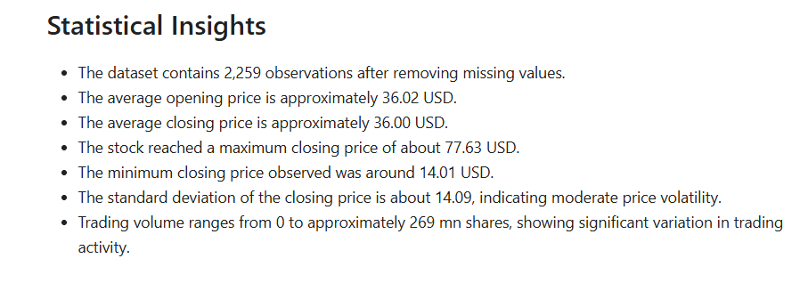
Fig.5 – Statistical Insights

Independent T-Test
Overview
An Independent T-Test was conducted to determine whether there was a statistically significant difference between Twitter’s High & Low stock prices. The test compares the mean value of the two variables to evaluate whether the observed difference is statistically significant.
Hypotheses
Null Hypothesis (H0): There is no statistically significant difference between the mean High and Low stock prices.
Alternative Hypothesis (H1): There is a statistically significant difference between the mean High and Low stock prices.
Results
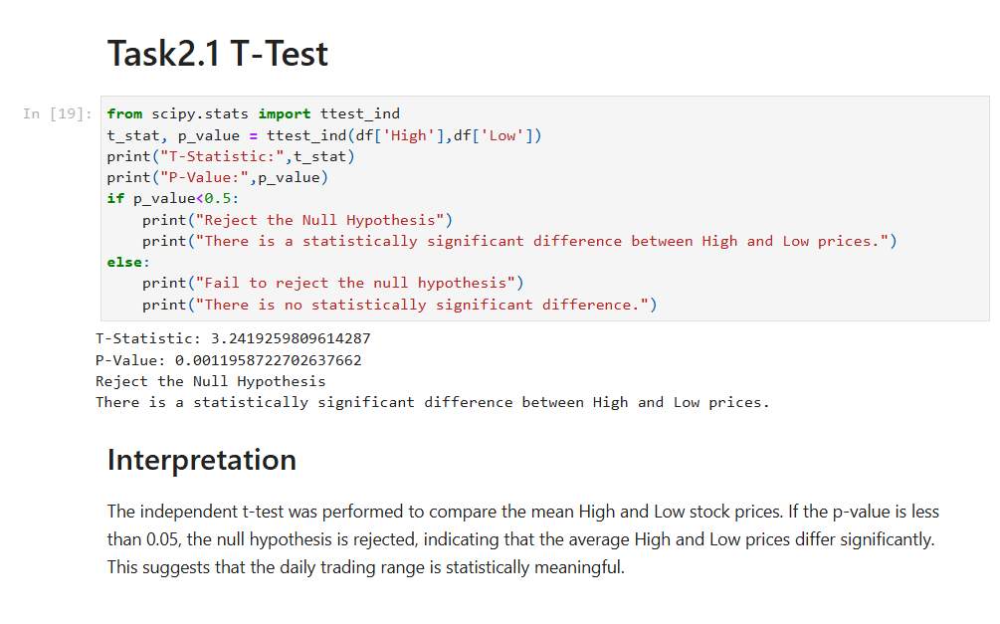
Fig.6 – T-Test

Chi-Square Test
Overview
A Chi-Square Test of Independence was conducted to determine whether there is a significant association between Twitter’s categorized High and Close stock prices. The test evaluates whether the two variables are statistically dependent or independent.
Hypotheses
Null Hypothesis (H0): There is no significant association between the categorized High and Close stock prices.
Alternative Hypothesis (H1): There is a significant association between the categorized High and Close stock prices.
Results
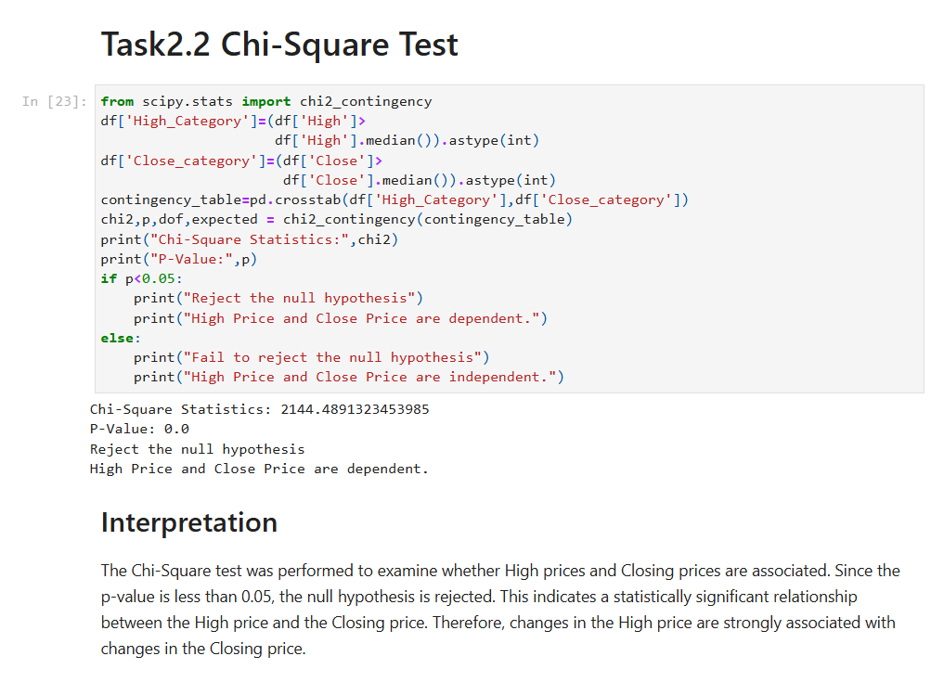
Fig.7 – Chi-Square Test

Stock Price Trend Over The Years
Overview
A line chart was created to visualize Twitter’s closing stock price from 2018-2024. This visualization helps identify long-term trends, period of growth, and market volatility.
Result
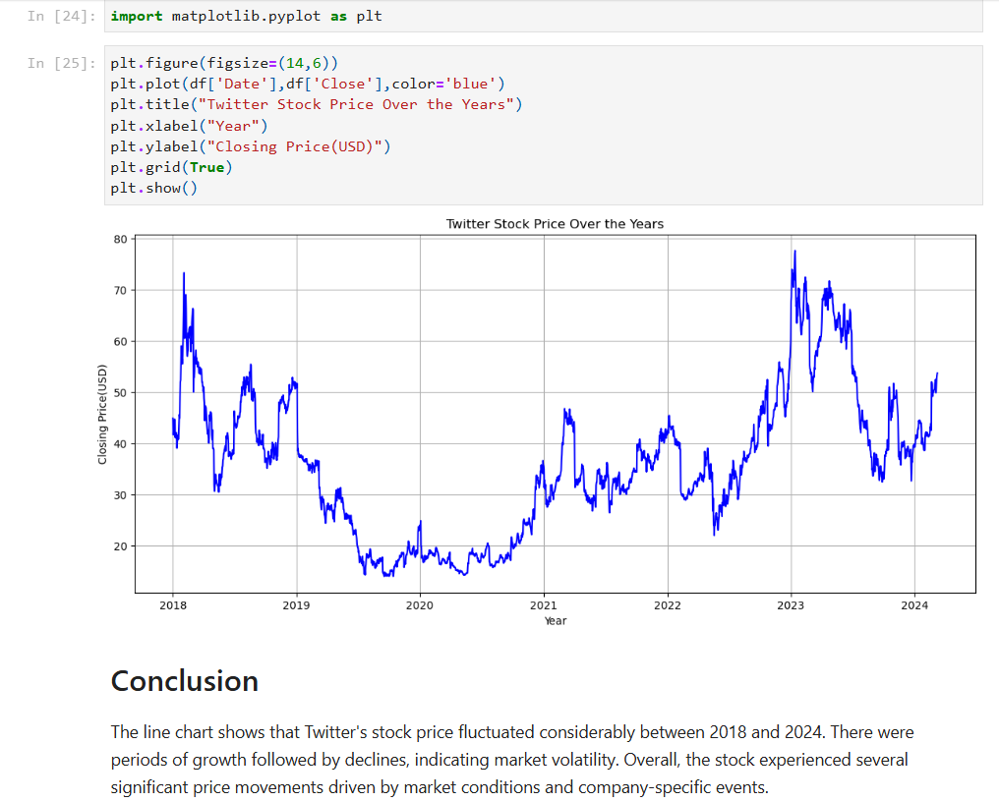
Fig.8 – Twitter Stock Price Trend (2018-24)
Interpretation
The stock price exhibited significant fluctuations over the analysis period. While there were periods of steady growth, the market also experienced sharp declines, reflecting changes in investor sentiment and broader market conditions. The visualization highlights the overall trend and helps identify periods of high volatility.

Close Price vs Date
Overview
This visualization presents the movement of Twitter’s closing stock price over time, providing a detailed view of daily price changes.
Results
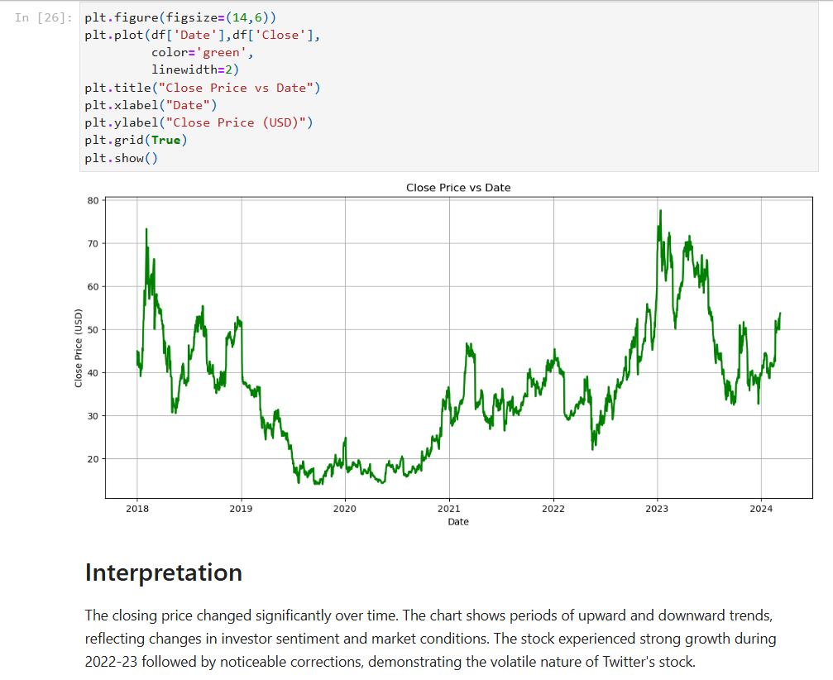
Fig.9 – Close Price vs Date

Interactive Plotly Visualization
Overview
An interactive stock price visualization was developed using the Plotly library in Python. Unlike static charts, this visualization allows users to dynamically explore Twitter’s stock price movements using built-in time filters and a range slider.
Features
The interactive visualization includes:
- Range Selector Buttons (1 Month, 6 Months, 1 Year & All)
- Range Slider for selecting custom time periods.
- Interactive zoom and pan functionality.
- Dynamic exploration of stock price trends.
Results
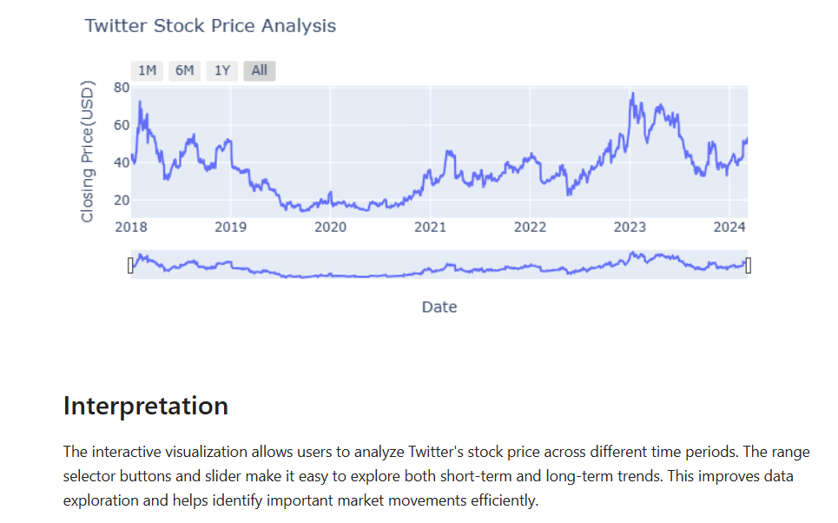
Fig.10 – Twitter Stock Price Analysis using Plotly

Complete Timeline Analysis
Overview
A complete timeline visualization was created to examine the Twitter’s stock price movement over the entire study period (2018-24). This visualization provides a comprehensive view of historical price trends and highlights major fluctuations over time.
Results
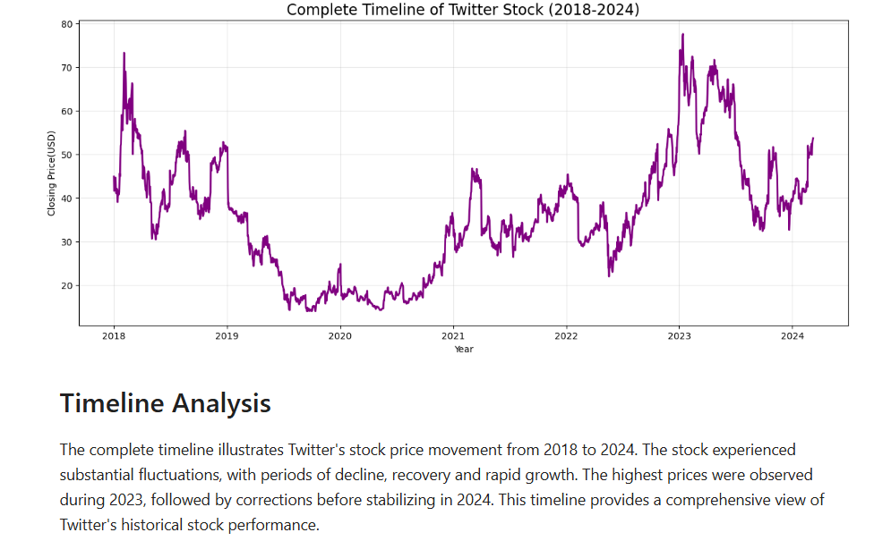
Fig.11 – Timeline of Twitter Stock Price

Word Cloud & Key Insights
Overview
A Word Cloud was generated to visually summarize the most significant keywords identified during the stock market analysis. The visualization highlights the frequently occurring financial concepts and provides a quick overview of the project’s major themes.
Results
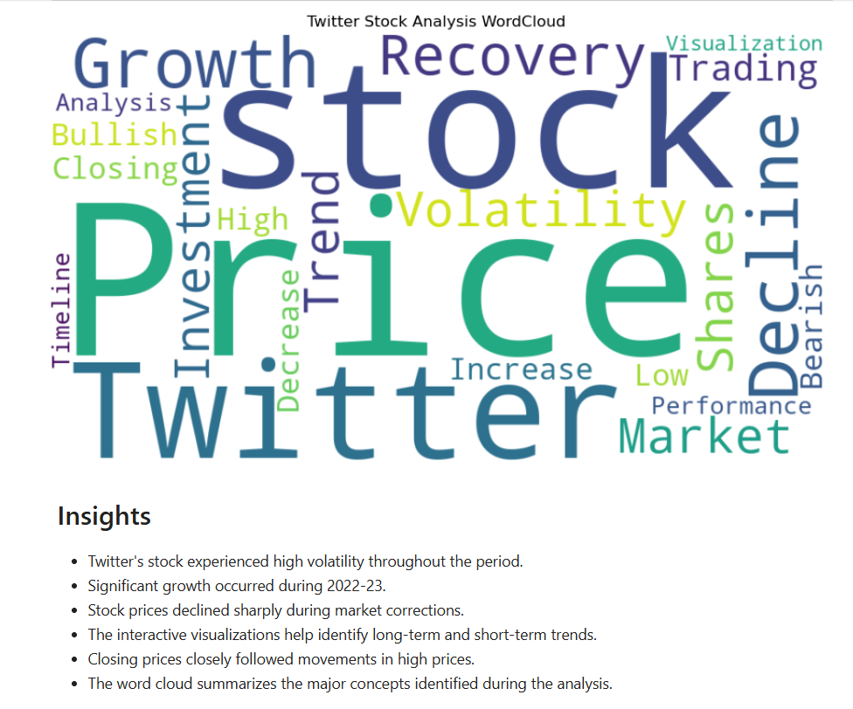
Fig.12 – Word Cloud of Twitter Stock Market Analysis

Power BI Dashboard
Overview
An interactive dashboard was developed in Power BI to present Twitter’s historical stock market data in a clear and user-friendly format. The dashboard combines key performance indicators (KPIs), trend visualizations and interactive filters to support efficient data exploration and business analysis.
Dashboard
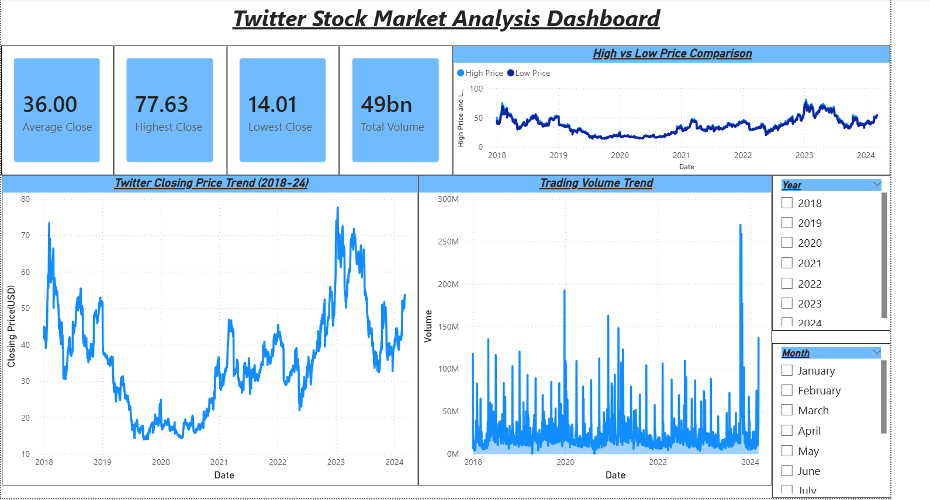
Fig.13 – Power BI Dashboard
Dashboard Components
The dashboard includes the following elements:
- KPI Cards
- Average Closing Price
- Highest Closing Price
- Lowest Closing Price
- Total Closing Price
- Visualizations
- Closing Price Trend
- Trading Volume Trend
- High vs Low Price Comparison
- Interactive Filters
- Year Slicer
- Month Slicer
Dashboard Insights
The Power BI dashboard enables users to:
- Monitor historical stock price trends over time.
- Compare daily High & Low prices.
- Analyse trading volume across different periods.
- Filter data by year & month for focused analysis.
- View key performance indicators at a glance.

Conclusion
Project Summary
This project successfully analysed Twitter’s historical stock market data using Python & Power BI. The analysis included data preprocessing, statistical evaluation, hypothesis testing, data visualization and dashboard development to better understand stock price movements and market behaviour.
Key Outcomes
- Successfully performed data cleaning and preprocessing.
- Conducted descriptive statistical analysis.
- Performed Independent T-Test and Chi-Square Test.
- Created static and interactive visualizations using Python.
- Designed an interactive Power BI dashboard.
- Generated meaningful business insights from historical stock market data.
Skills Demonstrated
Throughout this project, the following technical skills were applied:
- Python Programming
- Pandas
- NumPy
- Matplotlib
- Plotly
- Statistical Analysis
- Hypothesis Testing
- Data Cleaning
- Exploratory Data Analysis (EDA)
- Power BI
- Dashboard Design
- Business Insight Generation
Conclusion
This project demonstrates how historical stock market data can be transformed into meaningful insights through data analytics and visualization. The combination of Python for analysis and Power BI for interactive reporting provides a practical approach to financial data analysis and supports informed decision-making.

